Computer Language Coding Concepts

Parameters in an Active Clause in a Diagram
Parameters in an active clause have been conceptually explained in the article Parameters in an Active Clause.

This article only illustrates how parameters in an active clause look in a diagram.

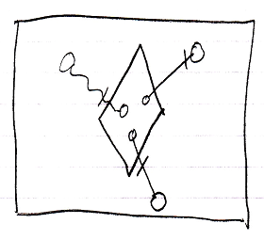

The large square is a command definition the inactive clause is in. The diamond inside the square is the active clause. The diamond contains three circles, which are the parameters in the clause. The circles inside the diamond are connected to the circles outside the diamond with parameter passings. Parameter passings are explained in the parameter articles.

See also: Parameters in an Active Clause

Author & Copyright: Jan-Joost van Zon Date: August 9, 2008 – August 14, 2008 Location: Oosterhout, The Netherlands Status: Finished

